PC Instructions to Combine Figures/Tables into One Image File

Step 1: Select “Start Menu”.
Step 2: Enter ‘Snipping Tool’ into the search field.
Step 3: Open the Snipping Tool program, then drag the cursor over the entire figure or table.
Step 4: Select “Start Menu”.
Step 5: Enter ‘Paint’ into the search field.
Step 6: Open the Paint program.
Step 7: In the bottom right corner, if the screen size is set as “zoom = 100%”, lower the screen size to 25% if you will insert more than one figure or image.
Step 8: Place your cursor at the bottom right corner of the white image box to expand the image to the full width of the screen.
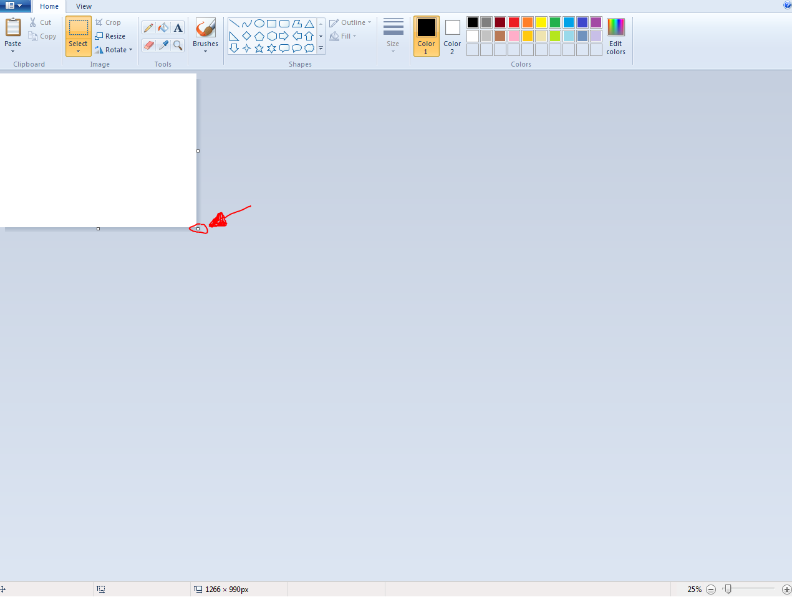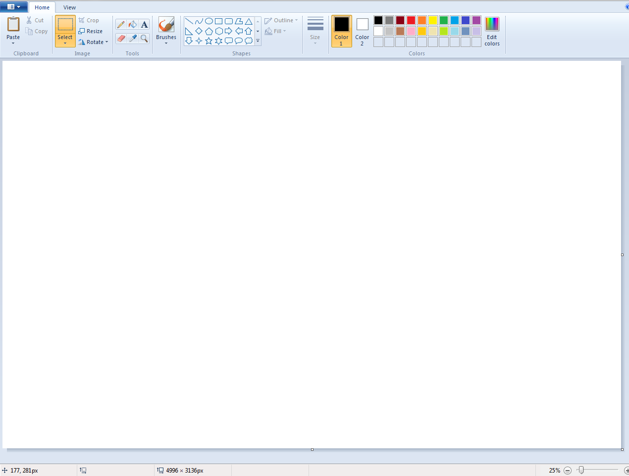
Step 9: Select “Paste” on the toolbar at the top of the screen to paste the first image.
Step 10: Repeat Step 3 to copy additional images.
Note: After selecting “paste”, to place each figure/table in the proper order in which they will appear, drag the image to the appropiate location on the screen.

Step 11: When all images and figures have been placed in the correct order that they will appear, remove any accessive empty space, otherwise the image upload will appear as shown below:
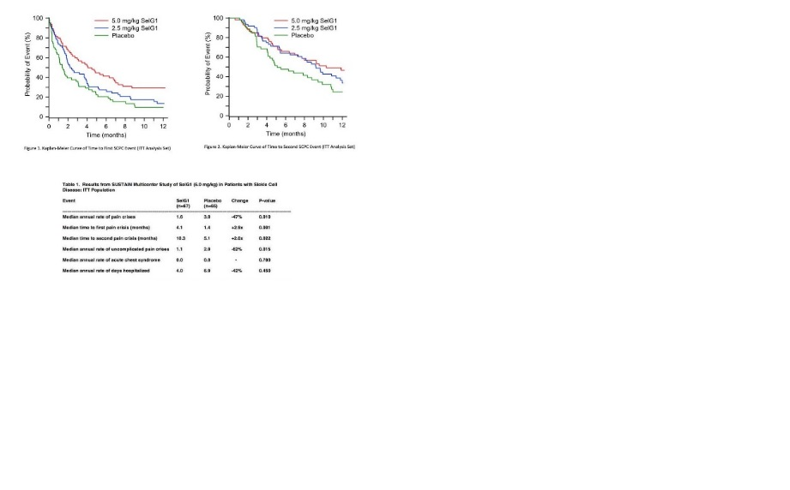
To remove the empty space, place the cursor in the lower right corner and move cursor to the left to resize the image.
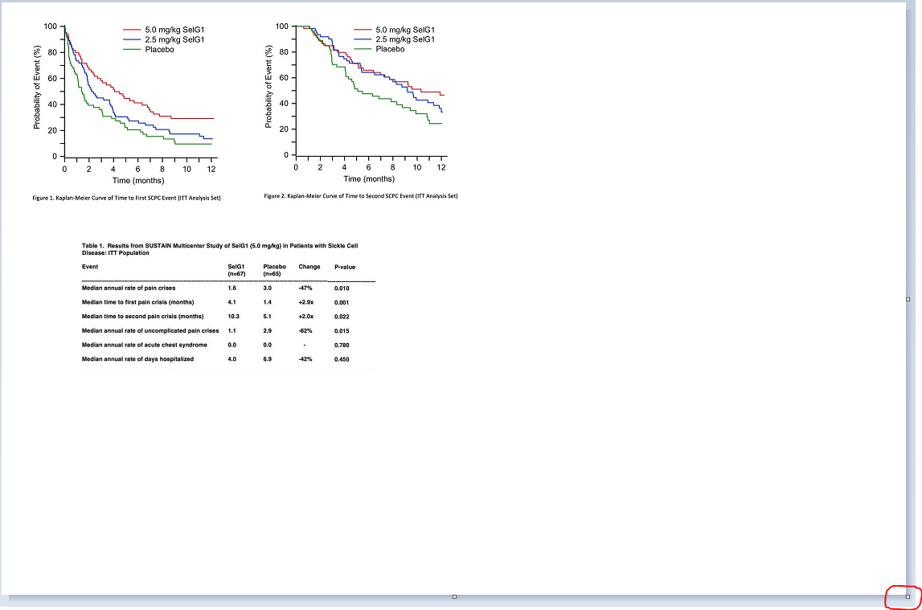
The resized image will upload as shown below:

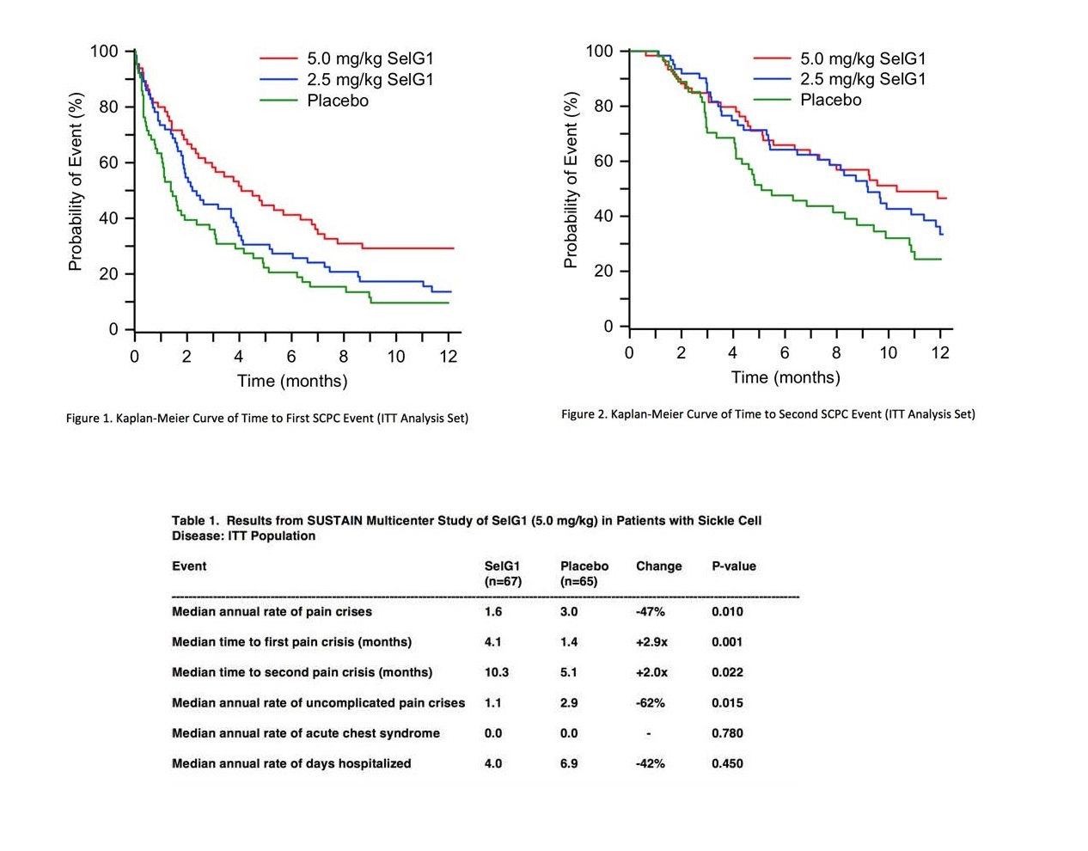
Step 12: After the image has been resized, select “Save as”.
Step 13: Enter the file name.
Step 14: Save the file type as a “JPEG (*.jpg;*.jpeg;*.jpe;*.jfif)”.
Step 15: Complete the image upload.

